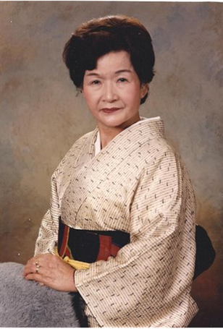



Boston Chapter No. 17

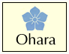

PRESENT
AKIKO HOSHO BOURLAND
GRAND MASTER OF THE OHARA SCHOOL OF IKEBANA
“HARMONY THROUGH FLOWERS”
IKEBANA (JAPANESE FLORAL) DEMONSTRATION
CELEBRATING THE SAKURA CENTENNIAL
APRIL 17, 2012 AT 9:30 AM
ESPOUSAL CENTER, 554 LEXINGTON ST. WALTHAM, MA

Enquiries: email Claire Benfatto, cjbenfatto@comcast.net
Joanne Caccavale, joanne.cc@verizon.net
Guest Fee: $15

